FinTech Lab Week 2 and Week 3

Q1 Create a bank database.

Ans:

The following bank database consists of three tables:

* Customer
* Credit
* Debit

The customer table has the following attributes:

* Customer_ID (integer value and primary key)
* Customer_name (varchar value)
* Address (varchar value)
* Phone_no (integer value)
* Email (varchar value)

Insert the rows into the table.

The SQL queries will be like so:

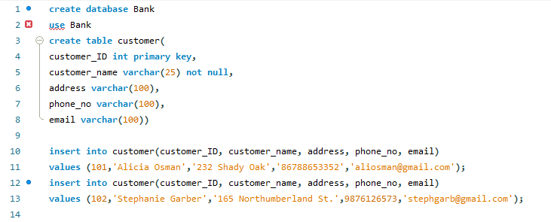

The credit table has the following attributes:

* Transaction_ID (integer value and primary key)
* Customer_ID (integer value and foreign key referencing customer table)
* Amount (integer value)
* Tansacton_dt (datetime value)

Insert the rows into the table.

The SQL queries will be like so:

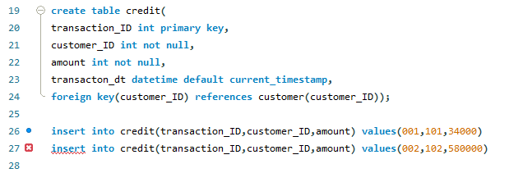

The debit table has the following attributes:

* Transaction_ID (integer value and primary key)
* Customer_ID (integer value and foreign key referencing customer table)
* Amount (integer value)
* Transaction_dt (datetime value)

Insert rows into table.

The SQL queries will be like so:

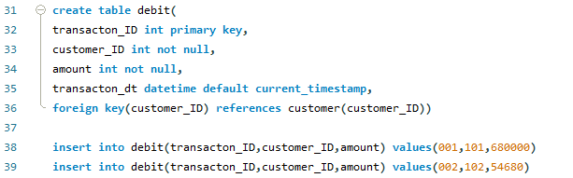

The ERD for the above tables Customer, Credit and Debit in the Bank database is as follows:

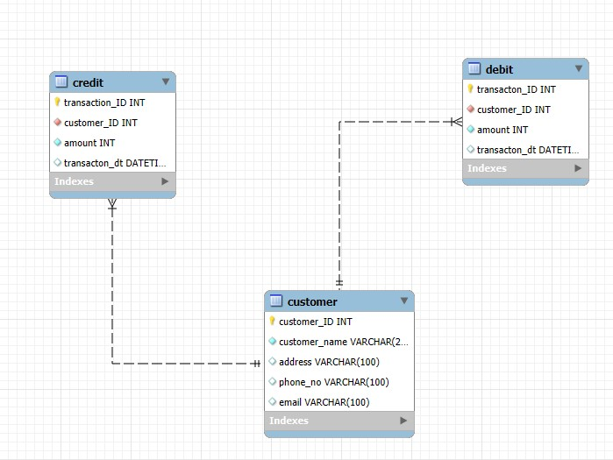

Q2 Create a Cricket Database.

Ans

The following Cricket database consists of three tables:

* Players
* Batting
* Bowling

The players table has the following attributes:

* Player_ID
* Player_name
* Team_name

Insert values into the table.

The SQL queries will be as follows:

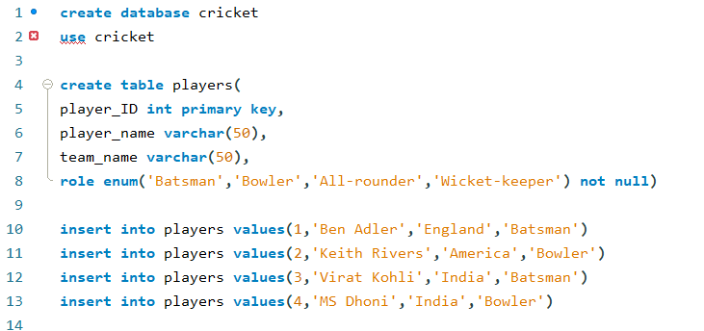

The batting table has the following attributes:

* Batting_ID
* Player_ID
* Matches_played
* Runs_scored
* Balls_faced
* Highest_score

Insert values into the table.

The SQL queries will be as follows:

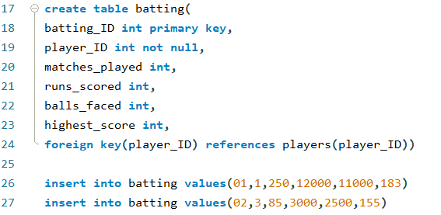

The bowling table has the following attributes:

* Bowling_ID
* Player_ID
* Matches_played
* Overs_bowled
* Wickets_taken
* Runs_conceded
* Best_figures

Insert values into the table.

The SQL queries are as follows:

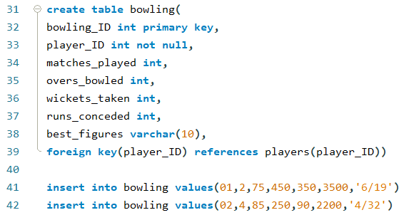

The ERD for the tables Players, Batting and Bowling in the Cricket DB will be:

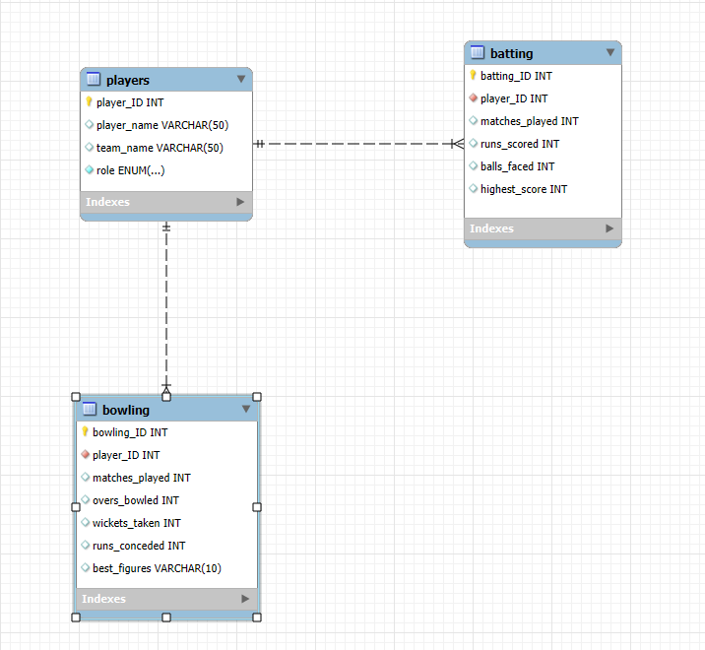

Week-3

Open up springboot and create a Maven Project named bndb with dependencies:

* Spring Web
* MySQL Driver
* Spring Data JPA

Generate, download and extract the maven file to the desired location.

Go to: src/main/resources and open application.properties and modify the file to:

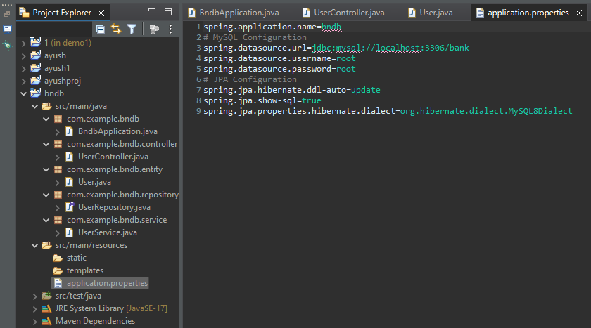

Then create a new package called com.example.bndb.entity and create a class in that package called ‘User’ as follows:

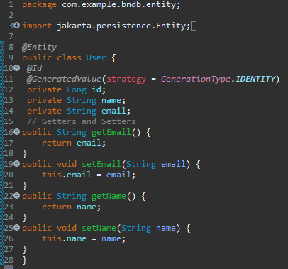

Create another package called com.example.bndb.service and inside it create a class called UserService as follows:

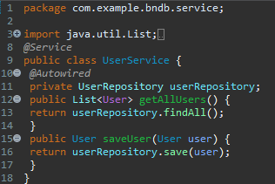

Create another package called com.example.bndb.repository and create a class UserRepository

